EXERCISE-1

1.create a table name STUDENT with following structure.

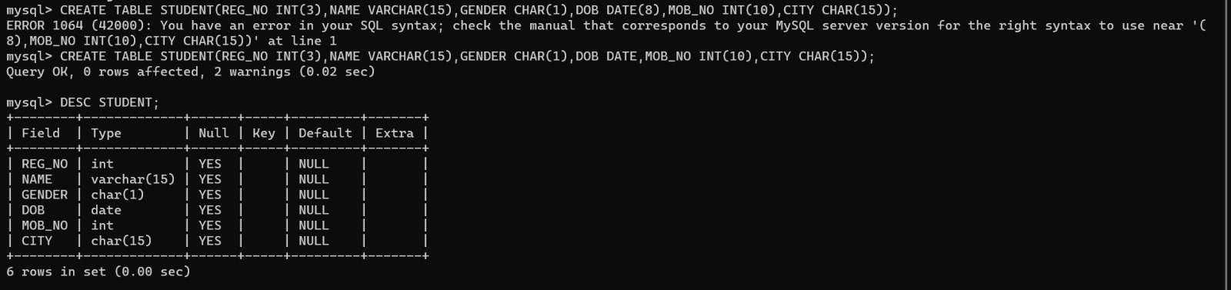

2.create a table name FACULTY with following structure.

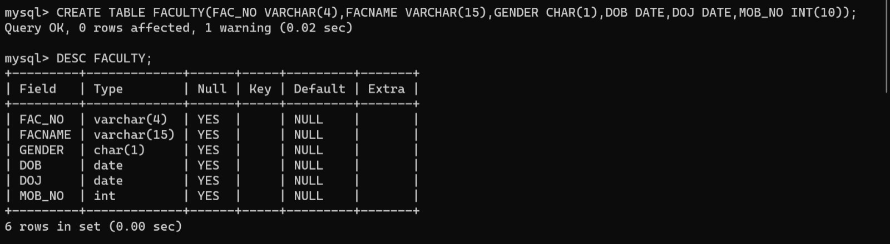

3.create a table name DEPARTMENT with following structure

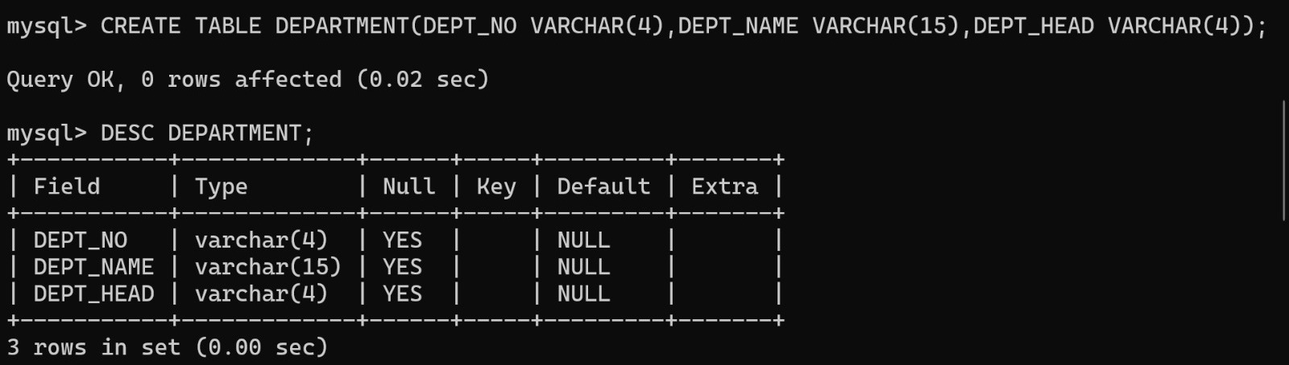

4.create a table name COURSE with the following structure.

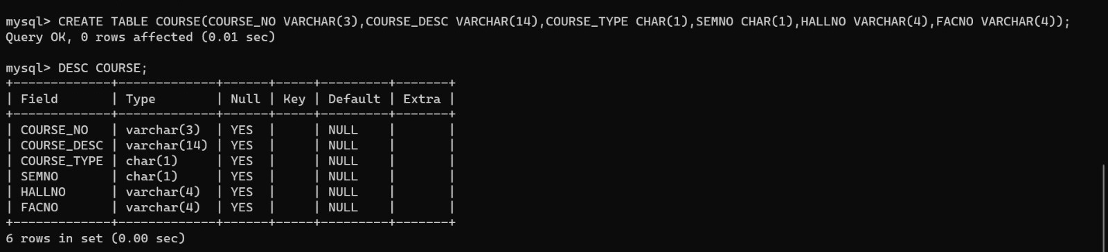

5.modify the table FACULTY by adding a column name deptno of datatype varchar(4).

